ARM 54, Tuesday, August 13th
Location – Holmes Murphy & Associates
12712 Park Central Drive
Dallas, Texas 75240
1st Floor

Hours
5:30pm – 7:30pm
Weekly meetings

Registration Information
Space is limited to 20 per class.
Please register early.
NO REFUNDS AFTER SECOND CLASS

Registration Fee
$160 – 14-week course

Register & pay online at
https://www.acteva.com/go/dfw

Or mail registration form with payment to DFW RIMS:
c/o Greg Stitts
Holmes Murphy & Associates
12712 Park Central Drive
Dallas, Texas 75240

Questions?
Call Greg Stitts at
(214) 265-6625 or (972) 342-2256 ©
Email: gstitts@holmesmurphy.com
.

Associate in Risk Management Classes (ARM)

Fall Schedule

Near Highway 635 / 75
Dallas, Texas

Presented by

The Dallas/Fort Worth
Chapter of the

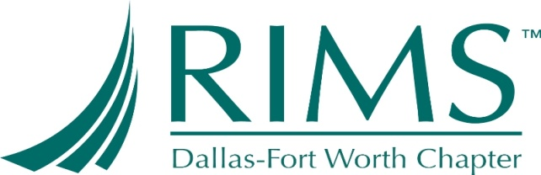

ARM: An Educational Program

The Associate in Risk Management (ARM) program is designed for people whose careers involve dealing in a cost-effective manner with exposures to accidental losses. Those who would benefit from the ARM program include corporate and governmental risk managers, safety personnel, insurance producers and consultants, and insurance company commercial lines specialists. More than 20,000 people who work in these fields have earned the designation.

The ARM program was developed by the Insurance Institute of America with technical and financial assistance from the Risk and Insurance Management Society (RIMS).

What the ARM Program Can Do for You
Earning the ARM designation can bring you:

- Expertise in an increasingly important discipline.
- Sharpened skills in risk control and risk financing
- Prestige and recognition as a risk management professional
- Broadened career opportunities

Students may receive credits toward an undergraduate or graduate degree for passing ARM exams. Also, many states, including Texas, grant continuing education credits for renewal of adjuster/insurance producers’ licenses to students who have passed ARM exams. Texas grants 15 CEU’s.

Earning the ARM Designation
The only requirement for earning the ARM designation is successful completion of three national ARM exams administered by the Institute. These exams are designed by risk managers, agents and brokers, and others whose careers focus on the risk management process.

Examination Schedule
- ARM 54/55/56: These exams are administered during the following testing windows. The exam periods are January 15 to March 15, April 15 to June 15, July 15 to September 15, October 15 to December 15
For specific information regarding exam dates, locations, books or other exam-related matters, please call the Institute at 1-800-644-2101 or log onto their Web site at www.aicpcu.org.

Although there is no required course sequence, ARM 54 is the most logical starting point. ARM 55 and ARM 56 may be taken in either order.

How to Get Started

- Order study materials. If your employer doesn’t have special procedures for ordering study materials and registering for the national exam, the easiest and fastest way to get started is to order on line at www.aicpcu.org or call 1-800-644-2101 and charge to your credit card.

- Register for a study class.

Registration Form

Yes! I would like to attend. Please enclose payment in the amount of $160 or register and pay online with credit card at https://www.acteva.com/go/dfw

ARM54 :

Name

Title

Company

Address

City

State Zip

Telephone

E-mail

( )Check made out to DFW RIMS

Register and pay online with credit card at https://www.acteva.com/go/dfw

OR
Mail to Greg Stitts
Holmes Murphy & Associates
12712 Park Central Drive
Dallas, Texas 75240 or
Fax form to 214/691-4639.
Email: gstitts@holmesmurphy.com

